Infosys Springboard Virtual Internship 6.0 Completion Report

Team Details
Batch Number : 10
Internship Duration: 8 Weeks
Start date : 26-NOV-25
Name: Prathyusha Yekamba

Project Title
Inventra – Intelligent Inventory Management System

Project Objective
- Prevent stock shortages and excess inventory across organizations
- Enable batch-wise and expiry-aware inventory tracking for all products
- Improve operational reliability by ensuring only valid and usable items are managed
- Automate stock alerts, approvals, and inter-location inventory transfers
- Provide data-driven insights for administrators and supply-chain teams
- Maintain secure, auditable, and compliant inventory operations
- Ensure real-time tracking of products across multiple locations, warehouses, and units

Project Description in Detail
Inventra – Intelligent Inventory Management System is designed to address key challenges in modern inventory management, where delays, manual processes, and lack of real-time visibility can lead to inefficiencies and operational risks. The system provides an integrated digital platform to manage products, materials, kits, and assets across multiple branches, warehouses, and distributed units.

The system continuously monitors stock levels, batch details, and expiry information using automated rules and validation checks. A First-Expiry-First-Out (FEFO) logic ensures that older and near-expiry batches are prioritized during usage or dispatch, while expired or invalid items are automatically restricted from further processing. Real-time synchronization across all locations ensures that inventory updates are instantly reflected, reducing data mismatches and manual reconciliation errors.
An intelligent alert engine generates notifications for low stock levels, expiry risks, damaged items, and delayed transfers. Secure inter-location stock transfer workflows include approval checkpoints, transit tracking, and reconciliation mechanisms to prevent losses and ensure accountability. A centralized dashboard provides administrators with complete visibility into inventory health, usage patterns, compliance status, and operational readiness. Overall, the system transforms traditional inventory handling into a smart, secure, and data-driven inventory management ecosystem.

Timeline Overview

Week | Activities Planned | Activities Completed
Week 1 | Project kickoff, understanding inventory management challenges, requirement analysis | Conducted project initiation meeting, finalized project scope, studied existing inventory management systems
Week 2 | Design data models for products, batches, expiry, and locations | Created product, batch, expiry, and stock location schemas
Week 3 | Define inventory workflows and expiry handling rules | Implemented FEFO logic, expiry validation, and stock blocking rules
Week 4 | Develop core inventory and alert modules | Built stock update, low-stock alerts, and expiry notification features
Week 5 | Design inter-branch stock transfer process | Implemented transfer requests, approval flow, and transit tracking
Week 6 | Testing and synchronization validation | Tested real-time stock sync, alert accuracy, and reconciliation logic
Week 7 | Dashboard and reporting module development | Developed inventory dashboards and compliance reports
Week 8 | Documentation, presentation, and final submission | Completed documentation, prepared presentation, and delivered demo

5a. Key Milestones

Milestone | Description | Date Achieved
Project Kickoff | Initial project briefing, problem identification, scope finalization, and system architecture planning | Week 1
Prototype / First Draft | Completion of basic inventory module, batch-wise tracking, and expiry handling logic | Week 3
Mid-Term  Review | Review of workflows, alert mechanisms, inter-branch transfer logic, and performance validation | Week 5
Final Submission | Completion of full system integration, dashboard, testing, and documentation | Week 7
Presentation | Final demonstration of smart inventory workflows and system features | Week 8

5b. Project Execution Details

- Followed a structured development approach starting with requirement analysis and system design.
- Technologies used: Java, Spring Boot, MySQL, REST APIs, and dashboard visualization tools.
- Modeled products with batch numbers, expiry dates, storage attributes, and location mapping.
- Implemented automated FEFO logic for efficient stock usage.
- Enabled real-time stock updates using transactional operations.
- Implemented role-based access control for employees, managers, and administrators.
- Developed alert engine for low stock, near-expiry, and delayed transfers.
- Performed comprehensive testing to ensure reliability and accuracy.

6.Snashots / Screenshots

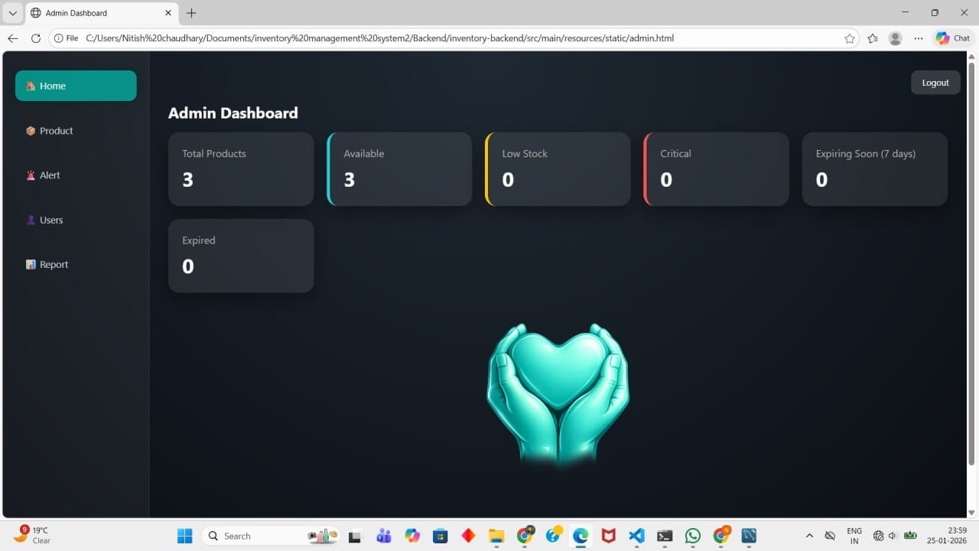

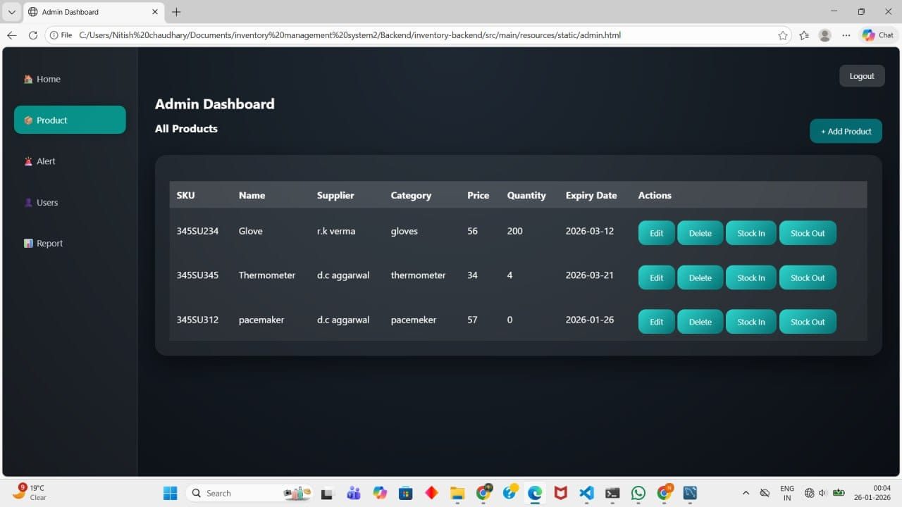
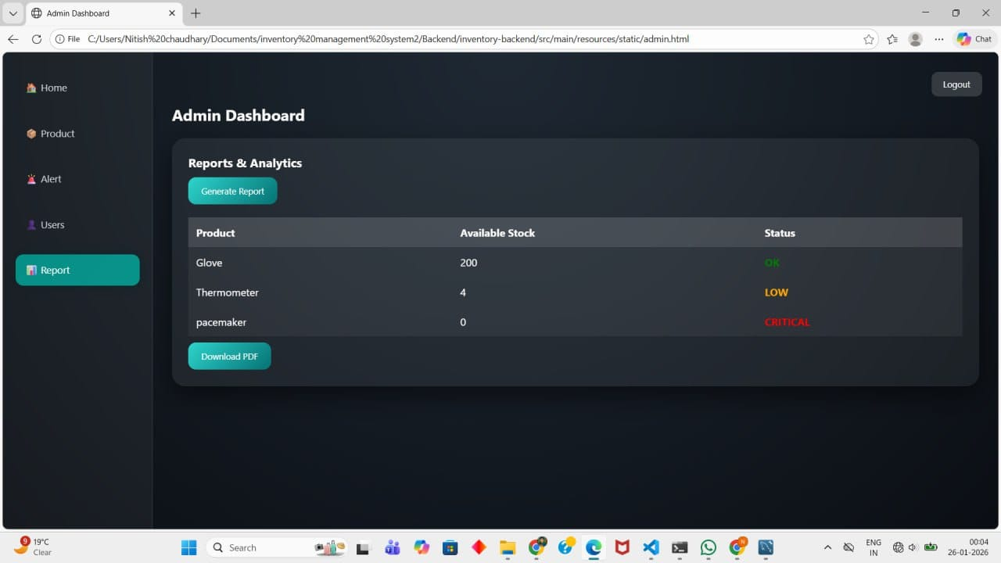

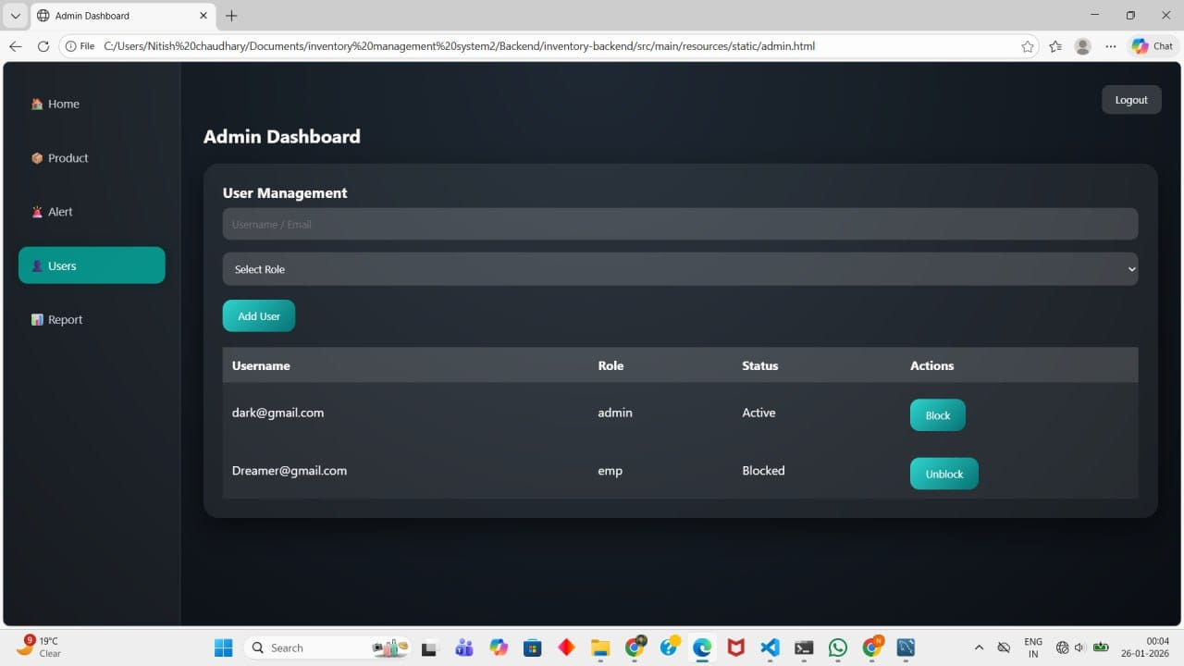

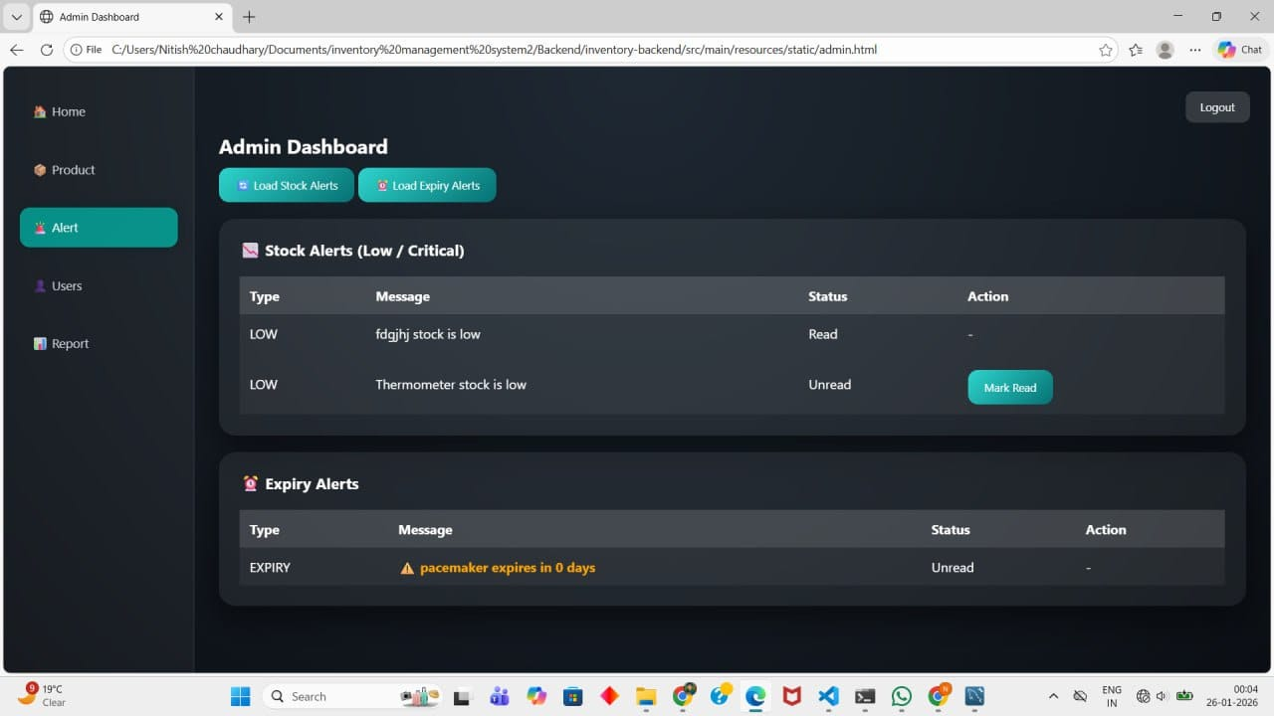

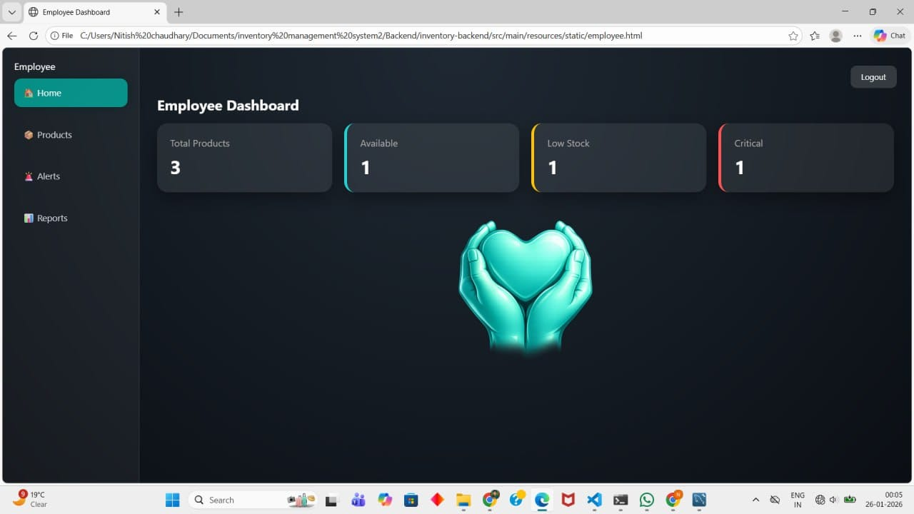
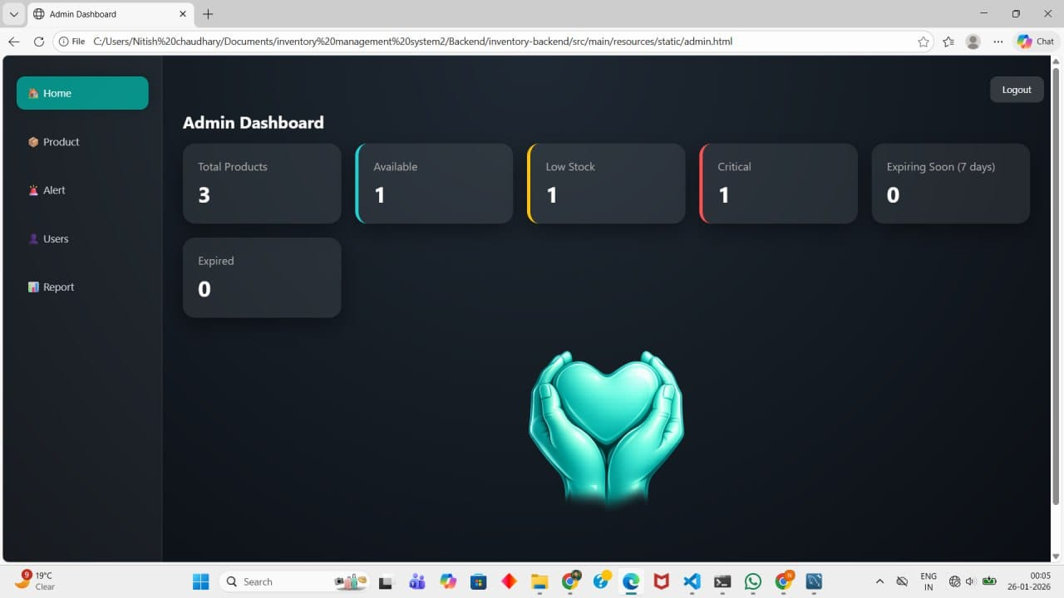

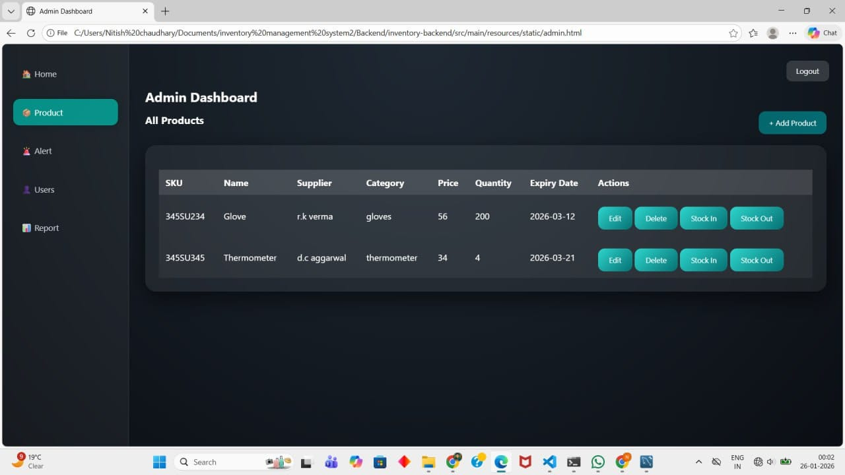

7. Learnings & Skills Acquired

The Inventra – Intelligent Inventory Management System project provided significant technical and practical learning related to enterprise inventory systems, reliable software design, and operational optimization. Throughout the internship, the team gained hands-on exposure to designing secure, scalable, and efficient solutions for real-world, multi-location inventory environments.
Key Learnings and Skills Acquired
- Inventory Management Systems: Gained a strong understanding of inventory workflows, including product storage, asset tracking, and multi-location stock handling.
- Batch-wise & Expiry Management: Learned to design and implement FEFO (First-Expiry-First-Out) logic to ensure efficient stock utilization and operational compliance.
- System Design & Architecture: Developed skills in designing scalable, modular, and fault-tolerant systems suitable for multi-branch and distributed environments.
- Backend Development: Strengthened backend development skills using secure REST APIs, transaction handling, and robust validation mechanisms.
- Database Design: Learned to design relational database schemas for products, batches, stock locations, alerts, and audit logs.
- Alert & Notification Systems: Acquired experience in implementing automated alerts for low stock levels, near-expiry items, and transfer delays.
- Dashboard & Reporting: Gained skills in visualizing inventory data, operational metrics, and usage trends through interactive dashboards and reports.
- Testing & Quality Assurance: Learned systematic testing approaches to validate data accuracy, real-time synchronization, and business rules.
- Risk Management & Compliance Awareness: Understood the importance of data accuracy, accountability, and auditability in enterprise software systems.
- Team Collaboration & Communication: Improved teamwork, documentation, and presentation skills through structured milestones, reviews, and project demonstrations.

8. Challenges Faced
Challenge 1: Expiry Risk Management
Problem: Expired items appearing as usable stock.
Solution: Automated expiry rules and FEFO logic.
Challenge 2: Stock Synchronization
Problem: Mismatch across multiple branches.
Solution: Real-time update and reconciliation mechanisms.
Challenge 3: Emergency Stock Handling
Problem: Critical shortages during emergencies.
Solution: Priority alerts and reserved emergency stock rules.
Challenge 4: Manual Dependency
Problem: Human errors in approvals and tracking.
Solution: Automated workflows with audit logs.
Challenge 5: Performance with Large Data Volumes
Problem: Slow response time when handling thousands of product records.
Solution: Optimized database queries using indexing and pagination.

Challenge 6: Data Validation Issues
Problem: Incorrect batch numbers and expiry dates entered by users.
Solution: Implemented input validation, format checks, and dropdown-based selections.

Challenge 7: Security of Inventory Operations
Problem: Risk of unauthorized access or manipulation.
Solution: Applied role-based access control (RBAC) and authentication.

9. Self-Reflection

Working on the Inventra – Intelligent Inventory Management System provided valuable hands-on exposure to real-world enterprise inventory challenges. The project strengthened my problem-solving ability, system design skills, and confidence in building scalable backend solutions.

10. Conclusion

The Inventra – Intelligent Inventory Management System successfully demonstrates how modern technology can improve operational efficiency, transparency, and decision-making in inventory management. The project strengthened our technical, analytical, and collaborative skills while highlighting the importance of accuracy, accountability, and real-time visibility in enterprise systems.

11. Acknowledgements
We sincerely thank our mentor and the Infosys Springboard team for their continuous guidance, support, and encouragement throughout this internship. Their insights, reviews, and feedback were instrumental in shaping this project into a meaningful and valuable learning experience.

